

GMIT, Data Analytics
Programming and Scripting Project 2018
Fishers Iris Data

Contents

Abstract/Summary 3
1.0 Introduction 3
2.0 Aim/Objectives 3
3.0 Methods 4
5.0 Results and Analysis 5
6.0 Discussion 33
7.0 Conclusion 33

Abstract/Summary
The following analysis looks to meet the requirements of the Galway / Mayo Institute of Technology, Data Analytics, Programming and Scripting module Project 2018. The analysis looks to use the practical Python programming skills learnt throughout the year within the Programming and Scripting module to analyze Fishers Iris Data Set.

1.0 Introduction
This analysis was carried out to use the practical Python programming skills learnt throughout the year within the Programming and Scripting module to analyze Fishers Iris Data Set. The final program version looked to divide the data sets into characteristics that could be used to perform statistical analysis. The statistical tools used within the final program are as follows;
- Histograms
- Normality Tests
- Basic Descriptive Statistics (e.g. mean, standard deviation, min / max value)
- Box Plots
- 2-Sample t-Tests
Fishers Iris Data Set is a multivariate data set used as an example of linear discriminant analysis. The data was collected originally by Edgar Anderson and used by British statistician Ronald Fisher in his 1936 paper “ The use of multiple measurements in taxonomic problems as an example of linear discriminant analysis “. The data set includes a total of 150 samples of three species of Iris (Setosa, Vericolor, and Virginica) and details four features of each Iris (Sepal Length, Sepal Width, Petal Length and Petal Width). Fisher developed a linear discriminant model to distinguish the species from each other based off these features. The data set is also used as a typical test case for statistical classification techniques in machine learning.

2.0 Aim/Objectives
The objective of this study was to use the practical Python programming skills learnt throughout the year within the Programming and Scripting module to analyze Fishers Iris Data Set and be able to draw some statistical conclusions based on the results generated from the execution of the Python program.

3.0 Methods

The fourth-generation programming language Python was used to develop a program that could take the Fisher Iris Data Set in a comma separated values file (.csv) and divide the data into logical characteristics and features so statistical analysis could be performed. Examples of the Python methods used within the final program script were as follows;
- ‘if’ statements
- ‘else’ statements
- Numpy library imports
- SciPy library imports
- Matlplotlib library imports
Examples of statistical methods and tools used within the final script were as follows;
- Histograms
- Normality Tests
- Basic Descriptive Statistics (e.g. mean, standard deviation, min / max value)
- Box Plots
- 2-Sample t-Tests
In all hypothesis testing a confidence interval of 95% was used. A 2-sample ttest was utilized in this analysis instead of ANOVA testing as the author wanted to gain programming experience in the use of t-testing. A 2-sample t Test is a hypothesis test for two population means to determine whether they are significantly different.
The 2-sample t-test analyzes the difference between these two means to determine whether the difference is statistically significant. The hypotheses of a two-tailed test would be:
· H0: m1 - m2 = 0
· H1: m1 - m2 ≠ 0
If the test's p-value is less than your chosen significance level i.e. 0.05, you should reject the null hypothesis.
To conduct a 2-sample t-test, the two populations must be independent; in other words, the observations from the first sample must not have any bearing on the observations from the second sample.

Results and Analysis

Descriptive Statistics
The data below details the descriptive statistics in relation to the Iris Data Sets outputted from the Final Project test script developed. The data list below was broken down into class groupings from the original data set so statistical analysis could be completed.
SepalLength SepalWidth PetalLength PetalWidth Class
0 5.1 3.5 1.4 0.2 Iris-setosa
1 4.9 3.0 1.4 0.2 Iris-setosa
2 4.7 3.2 1.3 0.2 Iris-setosa
3 4.6 3.1 1.5 0.2 Iris-setosa
4 5.0 3.6 1.4 0.2 Iris-setosa
5 5.4 3.9 1.7 0.4 Iris-setosa
6 4.6 3.4 1.4 0.3 Iris-setosa
7 5.0 3.4 1.5 0.2 Iris-setosa
8 4.4 2.9 1.4 0.2 Iris-setosa
9 4.9 3.1 1.5 0.1 Iris-setosa
10 5.4 3.7 1.5 0.2 Iris-setosa
11 4.8 3.4 1.6 0.2 Iris-setosa
12 4.8 3.0 1.4 0.1 Iris-setosa
13 4.3 3.0 1.1 0.1 Iris-setosa
14 5.8 4.0 1.2 0.2 Iris-setosa
15 5.7 4.4 1.5 0.4 Iris-setosa
16 5.4 3.9 1.3 0.4 Iris-setosa
17 5.1 3.5 1.4 0.3 Iris-setosa
18 5.7 3.8 1.7 0.3 Iris-setosa
19 5.1 3.8 1.5 0.3 Iris-setosa
20 5.4 3.4 1.7 0.2 Iris-setosa
21 5.1 3.7 1.5 0.4 Iris-setosa
22 4.6 3.6 1.0 0.2 Iris-setosa
23 5.1 3.3 1.7 0.5 Iris-setosa
24 4.8 3.4 1.9 0.2 Iris-setosa
25 5.0 3.0 1.6 0.2 Iris-setosa
26 5.0 3.4 1.6 0.4 Iris-setosa
27 5.2 3.5 1.5 0.2 Iris-setosa
28 5.2 3.4 1.4 0.2 Iris-setosa
29 4.7 3.2 1.6 0.2 Iris-setosa
30 4.8 3.1 1.6 0.2 Iris-setosa
31 5.4 3.4 1.5 0.4 Iris-setosa
32 5.2 4.1 1.5 0.1 Iris-setosa
33 5.5 4.2 1.4 0.2 Iris-setosa
34 4.9 3.1 1.5 0.1 Iris-setosa
35 5.0 3.2 1.2 0.2 Iris-setosa
36 5.5 3.5 1.3 0.2 Iris-setosa
37 4.9 3.1 1.5 0.1 Iris-setosa
38 4.4 3.0 1.3 0.2 Iris-setosa
39 5.1 3.4 1.5 0.2 Iris-setosa
40 5.0 3.5 1.3 0.3 Iris-setosa
41 4.5 2.3 1.3 0.3 Iris-setosa
42 4.4 3.2 1.3 0.2 Iris-setosa
43 5.0 3.5 1.6 0.6 Iris-setosa
44 5.1 3.8 1.9 0.4 Iris-setosa
45 4.8 3.0 1.4 0.3 Iris-setosa
46 5.1 3.8 1.6 0.2 Iris-setosa
47 4.6 3.2 1.4 0.2 Iris-setosa
48 5.3 3.7 1.5 0.2 Iris-setosa
49 5.0 3.3 1.4 0.2 Iris-setosa
SepalLength SepalWidth PetalLength PetalWidth Class
50 7.0 3.2 4.7 1.4 Iris-versicolor
51 6.4 3.2 4.5 1.5 Iris-versicolor
52 6.9 3.1 4.9 1.5 Iris-versicolor
53 5.5 2.3 4.0 1.3 Iris-versicolor
54 6.5 2.8 4.6 1.5 Iris-versicolor
55 5.7 2.8 4.5 1.3 Iris-versicolor
56 6.3 3.3 4.7 1.6 Iris-versicolor
57 4.9 2.4 3.3 1.0 Iris-versicolor
58 6.6 2.9 4.6 1.3 Iris-versicolor
59 5.2 2.7 3.9 1.4 Iris-versicolor
60 5.0 2.0 3.5 1.0 Iris-versicolor
61 5.9 3.0 4.2 1.5 Iris-versicolor
62 6.0 2.2 4.0 1.0 Iris-versicolor
63 6.1 2.9 4.7 1.4 Iris-versicolor
64 5.6 2.9 3.6 1.3 Iris-versicolor
65 6.7 3.1 4.4 1.4 Iris-versicolor
66 5.6 3.0 4.5 1.5 Iris-versicolor
67 5.8 2.7 4.1 1.0 Iris-versicolor
68 6.2 2.2 4.5 1.5 Iris-versicolor
69 5.6 2.5 3.9 1.1 Iris-versicolor
70 5.9 3.2 4.8 1.8 Iris-versicolor
71 6.1 2.8 4.0 1.3 Iris-versicolor
72 6.3 2.5 4.9 1.5 Iris-versicolor
73 6.1 2.8 4.7 1.2 Iris-versicolor
74 6.4 2.9 4.3 1.3 Iris-versicolor
75 6.6 3.0 4.4 1.4 Iris-versicolor
76 6.8 2.8 4.8 1.4 Iris-versicolor
77 6.7 3.0 5.0 1.7 Iris-versicolor
78 6.0 2.9 4.5 1.5 Iris-versicolor
79 5.7 2.6 3.5 1.0 Iris-versicolor
80 5.5 2.4 3.8 1.1 Iris-versicolor
81 5.5 2.4 3.7 1.0 Iris-versicolor
82 5.8 2.7 3.9 1.2 Iris-versicolor
83 6.0 2.7 5.1 1.6 Iris-versicolor
84 5.4 3.0 4.5 1.5 Iris-versicolor
85 6.0 3.4 4.5 1.6 Iris-versicolor
86 6.7 3.1 4.7 1.5 Iris-versicolor
87 6.3 2.3 4.4 1.3 Iris-versicolor
88 5.6 3.0 4.1 1.3 Iris-versicolor
89 5.5 2.5 4.0 1.3 Iris-versicolor
90 5.5 2.6 4.4 1.2 Iris-versicolor
91 6.1 3.0 4.6 1.4 Iris-versicolor
92 5.8 2.6 4.0 1.2 Iris-versicolor
93 5.0 2.3 3.3 1.0 Iris-versicolor
94 5.6 2.7 4.2 1.3 Iris-versicolor
95 5.7 3.0 4.2 1.2 Iris-versicolor
96 5.7 2.9 4.2 1.3 Iris-versicolor
97 6.2 2.9 4.3 1.3 Iris-versicolor
98 5.1 2.5 3.0 1.1 Iris-versicolor
99 5.7 2.8 4.1 1.3 Iris-versicolor
SepalLength SepalWidth PetalLength PetalWidth Class
100 6.3 3.3 6.0 2.5 Iris-virginica
101 5.8 2.7 5.1 1.9 Iris-virginica
102 7.1 3.0 5.9 2.1 Iris-virginica
103 6.3 2.9 5.6 1.8 Iris-virginica
104 6.5 3.0 5.8 2.2 Iris-virginica
105 7.6 3.0 6.6 2.1 Iris-virginica
106 4.9 2.5 4.5 1.7 Iris-virginica
107 7.3 2.9 6.3 1.8 Iris-virginica
108 6.7 2.5 5.8 1.8 Iris-virginica
109 7.2 3.6 6.1 2.5 Iris-virginica
110 6.5 3.2 5.1 2.0 Iris-virginica
111 6.4 2.7 5.3 1.9 Iris-virginica
112 6.8 3.0 5.5 2.1 Iris-virginica
113 5.7 2.5 5.0 2.0 Iris-virginica
114 5.8 2.8 5.1 2.4 Iris-virginica
115 6.4 3.2 5.3 2.3 Iris-virginica
116 6.5 3.0 5.5 1.8 Iris-virginica
117 7.7 3.8 6.7 2.2 Iris-virginica
118 7.7 2.6 6.9 2.3 Iris-virginica
119 6.0 2.2 5.0 1.5 Iris-virginica
120 6.9 3.2 5.7 2.3 Iris-virginica
121 5.6 2.8 4.9 2.0 Iris-virginica
122 7.7 2.8 6.7 2.0 Iris-virginica
123 6.3 2.7 4.9 1.8 Iris-virginica
124 6.7 3.3 5.7 2.1 Iris-virginica
125 7.2 3.2 6.0 1.8 Iris-virginica
126 6.2 2.8 4.8 1.8 Iris-virginica
127 6.1 3.0 4.9 1.8 Iris-virginica
128 6.4 2.8 5.6 2.1 Iris-virginica
129 7.2 3.0 5.8 1.6 Iris-virginica
130 7.4 2.8 6.1 1.9 Iris-virginica
131 7.9 3.8 6.4 2.0 Iris-virginica
132 6.4 2.8 5.6 2.2 Iris-virginica
133 6.3 2.8 5.1 1.5 Iris-virginica
134 6.1 2.6 5.6 1.4 Iris-virginica
135 7.7 3.0 6.1 2.3 Iris-virginica
136 6.3 3.4 5.6 2.4 Iris-virginica
137 6.4 3.1 5.5 1.8 Iris-virginica
138 6.0 3.0 4.8 1.8 Iris-virginica
139 6.9 3.1 5.4 2.1 Iris-virginica
140 6.7 3.1 5.6 2.4 Iris-virginica
141 6.9 3.1 5.1 2.3 Iris-virginica
142 5.8 2.7 5.1 1.9 Iris-virginica
143 6.8 3.2 5.9 2.3 Iris-virginica
144 6.7 3.3 5.7 2.5 Iris-virginica
145 6.7 3.0 5.2 2.3 Iris-virginica
146 6.3 2.5 5.0 1.9 Iris-virginica
147 6.5 3.0 5.2 2.0 Iris-virginica
148 6.2 3.4 5.4 2.3 Iris-virginica
149 5.9 3.0 5.1 1.8 Iris-virginica

Below is the descriptive statistics outputted by the Final Python program based on each class of Iris broken down into a logical set from the original data set.
Descriptive Statistics for the Setosa Iris Data Set

The Mean of the SetosadataSepallength is 5.006
The Standard Deviation of the SetosadataSepallength is 0.348946987378
The Min Value of the SetosadataSepallength is 4.3
The Max Value of the SetosadataSepallength is 5.8
The Mean of the SetosadataSepalwidth is 3.418
The Standard Deviation of the SetosadataSepalwidth is 0.377194909828
The Min Value of the SetosadataSepalwidth is 2.3
The Max Value of the SetosadataSepalwidth is 4.4
The Mean of the SetosadataPetallength is 1.464
The Standard Deviation of the SetosadataPetallength is 0.171767284429
The Min Value of the SetosadataPetallength is 1.0
The Max Value of the SetosadataPetallength is 1.9
The Mean of the SetosadataPetalwidth is 0.244
The Standard Deviation of the SetosadataPetalwidth is 0.106131993291
The Min Value of the SetosadataPetalwidth is 0.1
The Max Value of the SetosadataPetalwidth is 0.6

Descriptive Statistics for the Versicolor Iris Data Set

The Mean of the VersicolordataSepallength is 5.936
The Standard Deviation of the VersicolordataSepallength is 0.510983365678
The Min Value of the VersicolordataSepallength is 4.9
The Max Value of the VersicolordataSepallength is 7.0
The Mean of the VersicolordataSepalwidth is 2.77
The Standard Deviation of the VersicolordataSepalwidth is 0.31064449134
The Min Value of the VersicolordataSepalwidth is 2.0
The Max Value of the VersicolordataSepalwidth is 3.4
The Mean of the VersicolordataPetallength is 4.26
The Standard Deviation of the VersicolordataPetallength is 0.465188133985
The Min Value of the VersicolordataPetallength is 3.0
The Max Value of the VersicolordataPetallength is 5.1
The Mean of the VersicolordataPetalwidth is 1.326
The Standard Deviation of the VersicolordataPetalwidth is 0.195765165441
The Min Value of the VersicolordataPetalwidth is 1.0
The Max Value of the VersicolordataPetalwidth is 1.8

Descriptive Statistics for the Virginica Iris Data Set

The Mean of the VirginicadataSepallength is 6.588
The Standard Deviation of the VirginicadataSepallength is 0.629488681391
The Min Value of the VirginicadataSepallength is 4.9
The Max Value of the VirginicadataSepallength is 7.9
The Mean of the VirginicadataSepalwidth is 2.974
The Standard Deviation of the VirginicadataSepalwidth is 0.319255383666
The Min Value of the VirginicadataSepalwidth is 2.2
The Max Value of the VirginicadataSepalwidth is 3.8
The Mean of the VirginicadataPetallength is 5.552
The Standard Deviation of the VirginicadataPetallength is 0.546347874527
The Min Value of the VirginicadataPetallength is 4.5
The Max Value of the VirginicadataPetallength is 6.9
The Mean of the VirginicadataPetalwidth is 2.026
The Standard Deviation of the VirginicadataPetalwidth is 0.271889683512
The Min Value of the VirginicadataPetalwidth is 1.4
The Max Value of the VirginicadataPetalwidth is 2.5

Hypothesis Testing (Normality Testing)

Analysis and comparison of each Iris classifications features was conducted. A 2-sample t Test was utilized to conduct this comparison. To use the 2-sample t test procedures, your samples should be normally distributed, note the 2-sample t test is accurate with non-normal data when the sample sizes are large i.e. greater than 15. The samples must also be independent.

Normality Test for the Setosa Iris Data Attributes
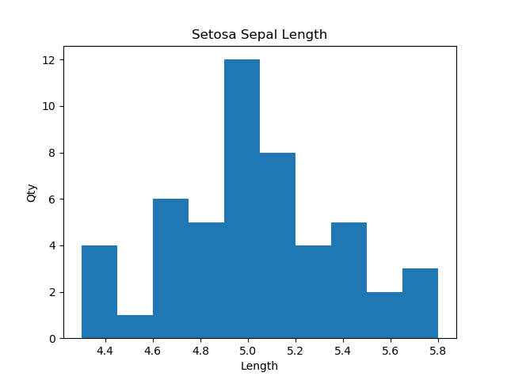
Normality Test for the Setosa Iris Data Attributes
p = 0.907482
We can fail to reject the null hypothesis for SetosadataSepallength the data follows the normal distribution
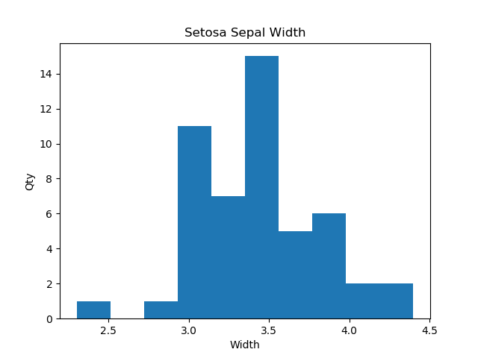
p = 0.388917
We can fail to reject the null hypothesis for SetosadataSepalwidth the data follows the normal distribution
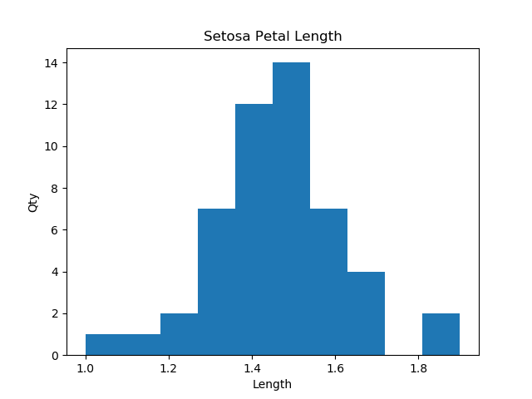
p = 0.332171
We can fail to reject the null hypothesis for SetosadataPetallength the data follows the normal distribution

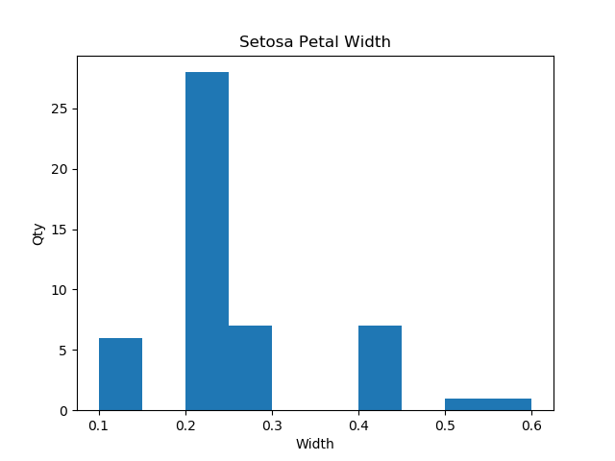
p = 0.00101905
We can reject the null hypothesis for SetosadataPetalwidth the data does not follows the normal distribution

Conducting a Normality Test for the Vericolor Iris Data Attributes
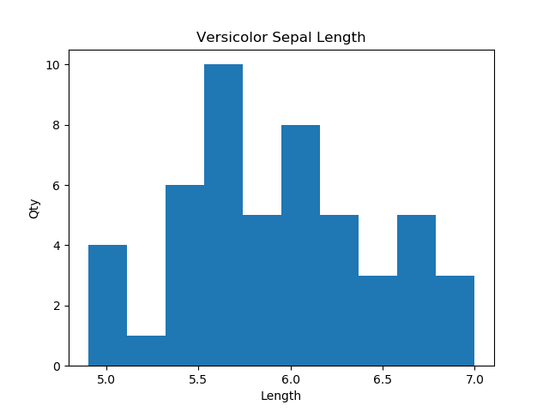
p = 0.656572
We can fail to reject the null hypothesis for VersicolordataSepallength the data follows the normal distribution

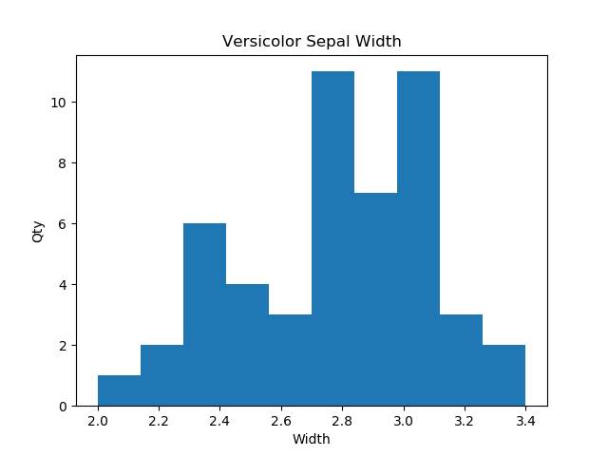
p = 0.484091
We can fail to reject the null hypothesis for VersicolordataSepalwidth the data follows the normal distribution

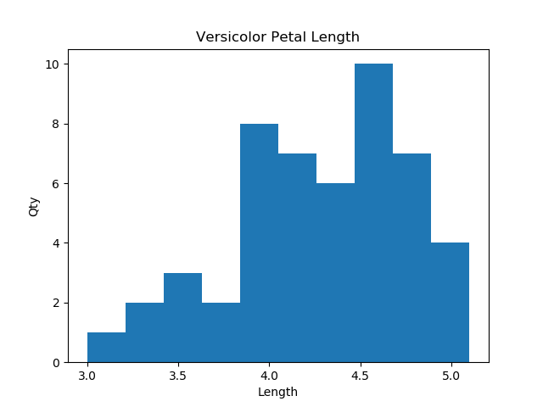
p = 0.190302
We can fail to reject the null hypothesis for VersicolordataPetallength the data follows the normal distribution

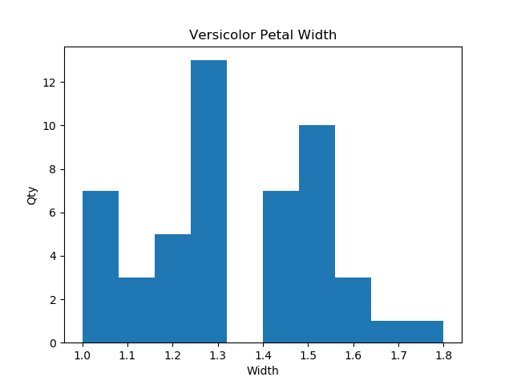
p = 0.84899
We can fail to reject the null hypothesis for VersicolordataPetalwidth the data follows the normal distribution

Conducting a Normality Test for the Virginica Iris Data Attributes
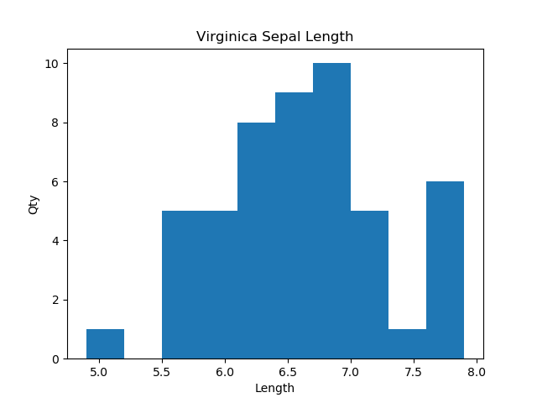
p = 0.90082
We can fail to reject the null hypothesis for VirginicadataSepallength the data follows the normal distribution

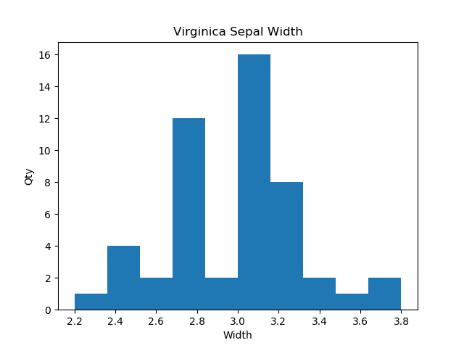
p = 0.277087
We can fail to reject the null hypothesis for VirginicadataSepalwidth the data follows the normal distribution

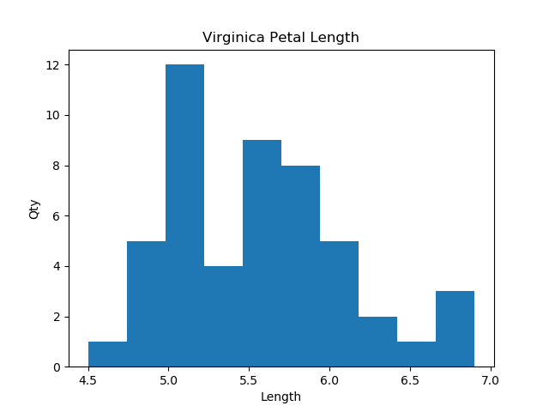
p = 0.259347
We can fail to reject the null hypothesis for VirginicadataPetallength the data follows the normal distribution

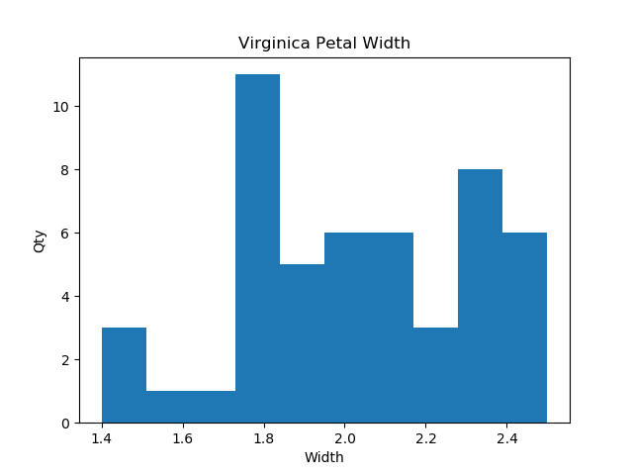
p = 0.538381
We can fail to reject the null hypothesis for VirginicadataPetalwidth the data follows the normal distribution

As can be seen from the graphs above all Iris classifications and associated features except for;
- Setosa Petal Width
follow a normal distribution and the P-Value’s exceed the required P-Value of 0.05. One of the pre-requisites for conducting a 2-sample t-Test is that both sample data sets to be analyzed follow a normal distribution. As the sample sizes for Setosa Petal Width are large the effect of non-normal data on the 2-sample t test is negated and this data set can be used without the need for executing a non-parametric hypothesis test.
In conducting the 2-sample t Test if the P-Value is greater than or equal to 0.05, the calculated t-Value is not outside the critical t-Value and if zero falls between the confidence interval for the mean differences we can fail to reject the null hypothesis that there is no significant statistical difference between the mean samples. If any of the requirements above are breach we can reject the null hypothesis.

Hypothesis Testing (2-Sample t Test) and Display of BoxPlots (as visual data aids)
Detailed below is the data output of the 2-sample t tests conducted across each class of Iris and each of their features from the final program script.

2-sample t test for SetosadataSepallength, VersicolordataSepallength
The t value of is -10.5209862675
The p value is 3.74674261398e-17
There is a Significant Statistical Difference between the Samples

As can be seen from the calculation above the P-Value does not exceed the critical P-Value of 0.05. As such we can reject the null hypothesis that there is no significant statistical difference between the mean samples for Setosa Sepal Length and Versicolor Sepal Length

2-sample t test for SetosadataSepallength, VirginicadataSepallength
The t value of is -15.3861958201
The p value is 3.96686727099e-25
There is a Significant Statistical Difference between the Samples
As can be seen from the calculation above the P-Value does not exceed the critical P-Value of 0.05. As such we can reject the null hypothesis that there is no significant statistical difference between the mean samples for Setosa Sepal Length and Virginica Sepal Length.

2-sample t test for VersicolordataSepallength, VirginicadataSepallength
The t value of is -5.62916525972
The p value is 1.86614438738e-07
There is a Significant Statistical Difference between the Samples
As can be seen from the calculation above the P-Value does not exceed the critical P-Value of 0.05. As such we can reject the null hypothesis that there is no significant statistical difference between the mean samples for Versicolor Sepal Length and Virginica Sepal Length.
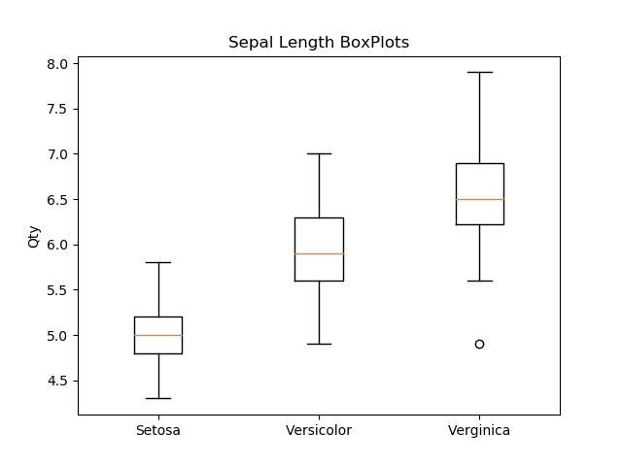

2-sample t test for SetosadataSepalwidth, VersicolordataSepalwidth
The t value of is 9.28277255556
The p value is 5.87960146841e-15
There is a Significant Statistical Difference between the Samples

As can be seen from the calculation above the P-Value does not exceed the critical P-Value of 0.05. As such we can reject the null hypothesis that there is no significant statistical difference between the mean samples for Setosa Sepal Width and Versicolor Sepal Width.

2-sample t test for SetosadataSepalwidth, VirginicadataSepalwidth
The t value of is 6.28938499667
The p value is 9.58603917038e-09
There is a Significant Statistical Difference between the Samples
As can be seen from the calculation above the P-Value does not exceed the critical P-Value of 0.05. As such we can reject the null hypothesis that there is no significant statistical difference between the mean samples for Setosa Sepal Width and Virginica Sepal Width.

2-sample t test for VersicolordataSepalwidth, VirginicadataSepalwidth
The t value of is -3.20576075022
The p value is 0.0018194834821
There is a Significant Statistical Difference between the Samples
As can be seen from the calculation above the P-Value does not exceed the critical P-Value of 0.05. As such we can reject the null hypothesis that there is no significant statistical difference between the mean samples for Versicolor Sepal Width and Virginica Sepal Width.

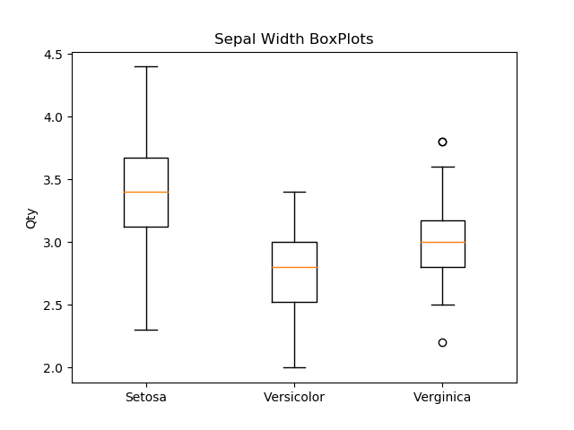

2-sample t test for SetosadataPetallength, VersicolordataPetallength

The t value of is -39.468662594

The p value is 1.05721003006e-45

There is a Significant Statistical Difference between the Samples

As can be seen from the calculation above the P-Value does not exceed the critical P-Value of 0.05. As such we can reject the null hypothesis that there is no significant statistical difference between the mean samples for Setosa Petal Length and Versicolor Petal Length.

2-sample t test for SetosadataPetallength, VirginicadataPetallength

The t value of is -49.9657033594

The p value is 9.7138670617e-50

There is a Significant Statistical Difference between the Samples

As can be seen from the calculation above the P-Value does not exceed the critical P-Value of 0.05. As such we can reject the null hypothesis that there is no significant statistical difference between the mean samples for Setosa Petal Length and Virginica Petal Length.

2-sample t test for VersicolordataPetallength, VirginicadataPetallength
The t value of is -12.6037794414
The p value is 4.9002875274e-22
There is a Significant Statistical Difference between the Samples
As can be seen from the calculation above the P-Value does not exceed the critical P-Value of 0.05. As such we can reject the null hypothesis that there is no significant statistical difference between the mean samples for Versicolor Petal Length and Virginica Petal Length.
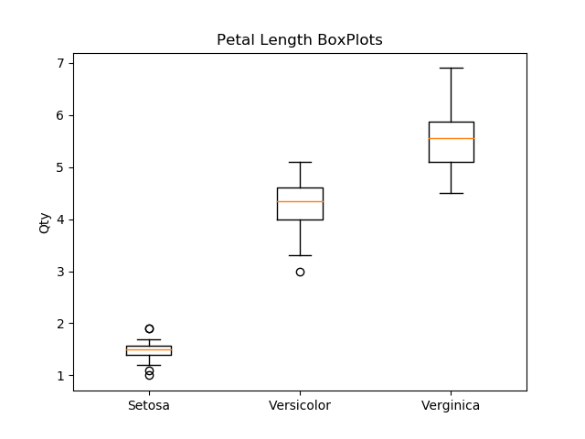

2-sample t test for SetosadataPetalwidth, VersicolordataPetalwidth
The t value of is -34.0123785883
The p value is 1.53779680513e-47
There is a Significant Statistical Difference between the Samples

As can be seen from the calculation above the P-Value does not exceed the critical P-Value of 0.05. As such we can reject the null hypothesis that there is no significant statistical difference between the mean samples for Setosa Petal Width and Versicolor Petal Width.

2-sample t test for SetosadataPetalwidth, VirginicadataPetalwidth
The t value of is -42.7382296724
The p value is 1.46674942465e-48
There is a Significant Statistical Difference between the Samples
As can be seen from the calculation above the P-Value does not exceed the critical P-Value of 0.05. As such we can reject the null hypothesis that there is no significant statistical difference between the mean samples for Setosa Petal Width and Virginica Petal Width.

2-sample t test for VersicolordataPetalwidth, VirginicadataPetalwidth
The t value of is -14.6253670474
The p value is 2.11153440099e-25
There is a Significant Statistical Di Difference between the Samples
As can be seen from the calculation above the P-Value does not exceed the critical P-Value of 0.05. As such we can reject the null hypothesis that there is no significant statistical difference between the mean samples for Versicolor Petal Width and Virginica Petal Width.
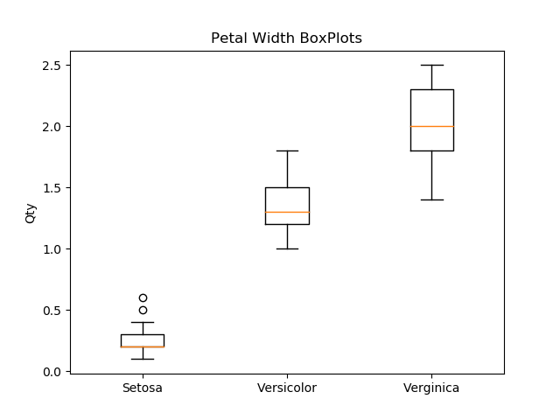

6.0 Discussion

The analysis carried out on Fishers Iris Data set has determined that the mean differences between each Iris species and their associated features are significantly different. The table below gives a synopsis of the results of carrying out a 2-sample t test on each of the Iris species related features.

Class / Feature | Null Hypothesis; No Significant Statistical Difference
 | Versicolor Sepal Length | Virginica Sepal Length
Setos Sepal Length | Reject | Reject
 | Versicolor Sepal Width | Virginica Sepal Width
Setos Sepal Width | Reject | Reject
 | Versicolor Petal Length | Virginica Petal Length
Setos Petal Length | Reject | Reject
 | Versicolor Petal Width | Virginica Petal Width
Setos Petal Width | Reject | Reject
 | Virginica Sepal Length
Versicolor Sepal Length | Reject
 | Virginica Sepal Width
Versicolor Sepal Width | Reject
 | Virginica Petal Length
Versicolor Petal Length | Reject
 | Virginica Petal Width
Versicolor Petal Width | Reject

On further review a better analytical tool to analyse multiple data sets would have been ANOVA, but for this project which was to demonstrate the use of the Python programming language the author wanted to use as many programming tools to available to illustrate the knowledge gained over the duration of the course.

7.0 Conclusion
As the means of the Iris species and their associated features are significantly different the use of machine learning could be developed and implemented through the Python programming language to predict an Iris’ species (i.e. Setosa, Versicolor, Virginica) and the concerned feature (i.e. Sepal Length, Sepal Width, Petal Length and Petal Width) based off the data inputted, by including a confidence interval around the means, variance and standard deviation an accurate prediction of what species has been studied with a stated confidence interval.

